DR-1200 Steam Cleaner System

Features: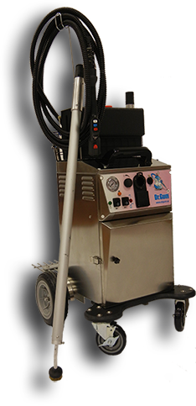
A large, heavy gauge stainless steel boiler with two external mounted heating elements provides more steam volume inside the boiler.
There are three shut down safety sensors mounted to the boiler.
DR-1200 delivers continuous dry steam at over 150*C / 300*F.
Dr. Gum manufactures lightweight aluminum wands that were developed to make any cleaning job more efficient and will also outperform the synthetic (plastic fiber) wands that other suppliers provide with their machines. With 3 control button, on the handle, activate continuous steam delivery (red), continuous solution delivery (blue), and the “as needed or on demand” solution delivery button (white). Our proprietary, non-toxic and bio
Dr. Gum offers the highest bristle count (density) in their brushes providing better value and longer Steam Cleaner Life span. Brushes are available in stainless steel, brass and/or nylon, large and small sizes that can be used on various surfaces.
Eco-friendly Dr. Gum cleaning solution was developed to emulsify a wad of gum in seconds and remove over 700 pieces of gum in per hour, from any surface.
The DR-1200 can be used to address both indoor and outdoor cleaning applications. Our steam cleaner system is pedestrian friendly. No need to schedule cleaning operations for late evenings or overnight.

